****Introduction to Computer Graphics****

Computer graphics is commonly seen as a computer science branch that deals with the computerized image fusion theory and technology. As simple as a triangle outline, a computer-generated image may represent a scene. The computer has become a powerful tool for producing images quickly and economically.

When a computer is used to create images, the same process is followed as creating images manually. The process's primary computational steps give a boost to several important computer graphics areas.

Also on computers, the term computer graphics covers almost everything. Here in the computer graphics program's classroom, we think of computer graphics as drawing images on machines, often known as ****rendering****. The images can be photos, sketches, animations, or pictures of items imagined. Or they may be pictures, we cannot see directly, like internal body parts.

We have put a great deal of our time to develop how computer images can replicate real-world scenes. We want objects on computers not only to look more real, but also their colors to be more realistic and how different materials appear. We can call it "real synthesis of the image."

The term computer graphics has been used to define "almost everything on the computer,  including text or sound." Generally, the term computer graphics refer to the following things:

* Computer representation and manipulation of image data.
* Various technologies for creating and manipulating images.
* Computer graphics study is a sub-field of computer science that studies methods for digitally incorporating and manipulating visual content.

The next area of computer graphics that deals with the placement of a triangle is called****transformation****. Here we can use matrices to get the mapping of a triangle in image space. We can also set up the transformation matrix to control the location and orientation of the displayed image. We can also resize the triangle.

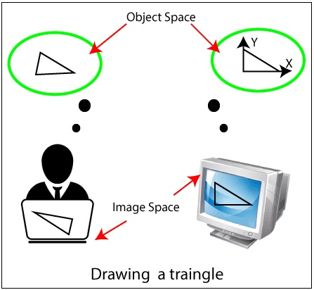

****Definition of Computer Graphics-****Computer graphics can be a series of images which is most often called a video or single image. Computer graphics is the technology that concerns with designs and pictures on computers. That’s why, computer graphics are visual representations of data shown on a monitor made on a computer.

“Computer graphics is the use of a computer to define, store, manipulate, interrogate, and represent the pictorial output.” An image in computer graphics is made up of a number of pixels.

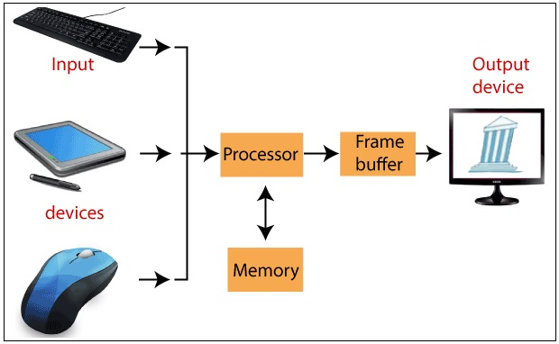

****Applications of Computer Graphics****

Some applications of computer graphics are mentioned below-

* ****Graphical User Interface (GUI):****It is a way of interacting with a computer using the icon, menu, and other visual, graphics by which user easily interacts.
* ****Art:**** Computer Graphics provides a new way of making designs. Many artists and designers use illustrator, coral draw, Photoshop, adobe muse, and other types of applications for creating new designs.
* ****Entertainment:****Computer graphics allow the user to make animated movies and games. Computer graphics are used to create scenes. Computer graphics are also used for special effects and animations.
* ****Presentations:****Computer graphics are used for making charts, bar diagrams, and other images for the presentation purpose, with the graphical presentation the user, can easily understand the points.
* ****Engineering Drawings:****Computer Graphics has also provided us the flexibility to make 3D models, house circuits and engineering drawings, etc. which is helpful for us.
* ****Education and Training:****Computer graphics are also used to provide training to students with simulators. The students can learn about the machines without physically trying them.
* ****Medical Imaging:****MRIs, CT scans, and other internal scans are possible because of computer graphics.
* ****Flight Simulator:**** Computer graphic is used to provide training to pilots of aircraft. The pilots give much time to a flight simulator on the ground instead of real airplanes.
* ****Printing Technology: Computer**** graphics are used in textile designing and flex printing.
* ****Typography:****Use of character pictures to replace the rough form of the past in printing.
* ****Satellite Imaging:****Computer graphics are used to forecast the movement of the cloud and to predict the weather.
* ****Cartography:****Computer graphics are used in map drawing.
* ****CAD****/****CAM:**** CAD/CAM is also known as Computer-aided design and computer-aided manufacturing. CAD/CAM is used to design and build prototypes, finished products, and manufacturing processes.

### **Advantages of Computer graphics**

Some important benefits of Computer graphics are:

* Increase Productivity
* Computer graphics give us tools for creating pictures of solid objects as well as of theoretical, engineered objects.
* Computer graphics also point out the moving images.
* The computer can store complex drawings and display complex pictures.
* Sound cards are used to make computers produce sound effects led to other uses of graphics.

****Disadvantages of Computer graphics:****Some problems with computer graphics are:

* Hardware characteristics and cost.
* Technical issues.
* Coupling issues (display-to-simulation).

Introduction to Computer Graphics Computer **pics** is **normally** **visible** as a **laptop** **technology** **department** that **offers** with the **automatic** **photo** fusion **concept** and **era**. As **easy** as a triangle outline, a **laptop**-generated **photo** **can also additionally** **constitute** a scene. The **laptop** has **turn out to be** a **effective** **device** for **generating** **pictures** **fast** and economically. When a **laptop** is used to create **pictures**, the **equal** **method** is **observed** as **growing** **pictures** manually. The **method**'s **number one** computational steps **supply** **a lift** to **numerous** **critical** **laptop** **pics** areas. Also on **computer systems**, the **time period** **laptop** **pics** covers **nearly** **the whole thing**. Here **withinside the** **laptop** **pics** program's classroom, we **consider** **laptop** **pics** as drawing **pictures** on machines, **frequently** **referred to as** rendering. The **pictures** **may be** photos, sketches, animations, or **images** of **objects** imagined. Or **they will** be **images**, we **can not** see directly, like **inner** **frame** parts. We have **placed** a **awesome** deal of our time to **increase** how **laptop** **pictures** can **reflect** **actual**-**international** scenes. We **need** **items** on **computer systems** **now no longer** **best** to **appearance** **extra** **actual**, **however** **additionally** their **colours** to be **extra** **practical** **and the way** **one-of-a-kind** **substances** appear. We can **name** it "**actual** synthesis of the **photo**." The **time period** **laptop** **pics** has been used to define "**nearly** **the whole thing** **at the** **laptop**,  **which include** **textual content** or sound." Generally, the **time period** **laptop** **pics** **check with** **the subsequent** things: •Computer **illustration** and manipulation of **photo** **information**. •Various **technology** for **growing** and manipulating **pictures**. •Computer **pics** **observe** is a sub-**area** of **laptop** **technology** that **research** **techniques** for digitally incorporating and manipulating **visible** content. The **subsequent** **vicinity** of **laptop** **pics** that **offers** with **the position** of a triangle is **known as** transformation. Here **we will** use matrices to get the mapping of a triangle in **photo** space. We **also can** **installation** the transformation matrix **to manipulate** the **area** and orientation of the displayed **photo**. We **also can** resize the triangle.  Definition of Computer Graphics-Computer **pics** **may be** **a chain** of **pictures** **that's** **most customarily** **known as** a video or **unmarried** **photo**. Computer **pics** is the **era** that **worries** with designs and **images** on **computer systems**. That’s why, **laptop** **pics** are **visible** representations of **information** **proven** on a **screen** made on a **laptop**. “Computer **pics** is **using** a **laptop** to define, **keep**, manipulate, interrogate, and **constitute** the pictorial output.” An **photo** in **laptop** **pics** is **made from** a num ber of pixels. Applications of Computer Graphics Some **programs** of **laptop** **pics** are **noted** below- •Graphical User Interface (GUI): It is a **manner** of interacting with a **laptop** **the usage of** the icon, menu, and **different** **visible**, **pics** **via way of means of** which **consumer** **effortlessly** interacts.  •Art: Computer Graphics **offers** **a brand new** **manner** **of creating** designs. Many artists **and architects** use illustrator, coral draw, Photoshop, adobe muse, and **different** **forms of** **programs** for **growing** new designs. •Entertainment: Computer **pics** **permit** the **consumer** to make **lively** **films** and games. Computer **pics** are used to create scenes. Computer **pics** **also are** used for **computer graphics** and animations. •Presentations: Computer **pics** are used for making charts, bar diagrams, and **different** **pictures** for the presentation purpose, with the graphical presentation the **consumer**, can **effortlessly** **apprehend** the points. •Engineering Drawings: Computer Graphics has **additionally** **supplied** us **the power** to make **3-d** models, **residence** circuits and engineering drawings, etc. **that's** **useful** for us. •Education and Training: Computer **pics** **also are** used to **offer** **education** to **college students** with simulators. The **college students** can **study** the machines **with out** **bodily** **attempting** them. •Medical Imaging: MRIs, CT scans, and **different** **inner** scans are **feasible** **due to** **laptop** **pics**. •Flight Simulator: Computer **photo** is used to **offer** **education** to pilots of aircraft. The pilots **supply** **a lot** time to a flight simulator **at the** **floor** **in preference to** **actual** airplanes. •Printing Technology: Computer **pics** are **utilized in** **fabric** designing and flex printing. •Typography: Use of **person** **images** to **update** the **hard** **shape** of the **beyond** in printing. •Satellite Imaging: Computer **pics** are used to forecast the **motion** of the cloud and to **expect** the weather. •Cartography: Computer **pics** are **utilized in** map drawing. • CAD/CAM: CAD/CAM **is likewise** **referred to as** Computer-aided **layout** and **laptop**-aided **production**. CAD/CAM is used to **layout** and **construct** prototypes, **completed** products, and **production** processes. Advantages of Computer **pics**  Some **critical** **advantages** of Computer **pics** are:  •Increase Productivity •Computer **pics** **supply** us **equipment** for **growing** **images** of **strong** **items** **in addition to** of theoretical, engineered **items**. •Computer **pics** **additionally** **factor** out the **shifting** **pictures**. •The **laptop** can **keep** **complicated** drawings and **show** **complicated** **images**. •Sound **playing cards** are used to make **computer systems** produce sound **results** **caused** **different** **makes use of** of **pics**. Disadvantages of Computer **pics**: Some **issues** with **laptop** **pics** are: •Hardware **traits** and cost. •Technical issues. •Coupling issues (**show**-to-simulation).